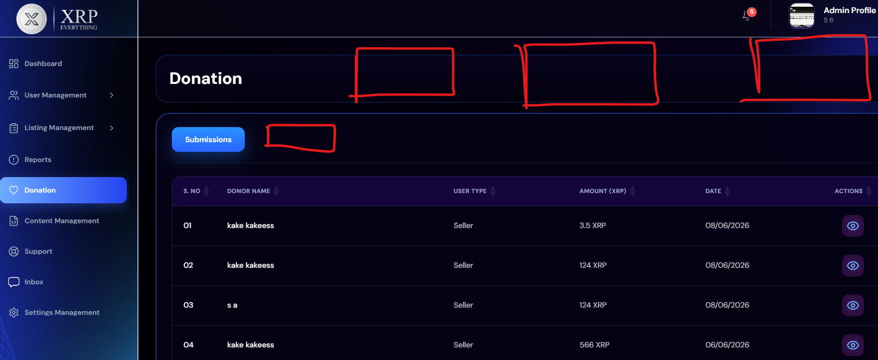
Cards are missing as figma design and also setup section is missing

